library("ChemoSpec2D")

## Loading required package: ChemoSpecUtils data(MUD2)

set.seed(123)

MUD2a <- hats_alignSpectra2D(MUD2 maxF1 = 5, maxF2 = 5,

dist_method = "euclidean", thres = 40, minimize = TRUE, fill = "noise",

plot = FALSE)

## This is a beta version of hats_alignSpectra2D.

## You should set the seed for reproducible results.

## Please check your results carefully, and consider sharing your data ## for additional testing.

|  |  |  |  |
| --- | --- | --- | --- |
| ## | [ChemoSpec2D] Processing row 1 of 9 from the guide | tree: |  |
| ## | [ChemoSpec2D] Starting alignment of sample(s) 7 |  |
| ## | with sample(s) 4 |  |
| ## | [ChemoSpec2D] Best alignment is to shift F2 by 0 and | F1 by | -1 |
| ## |  |  |  |
| ## | [ChemoSpec2D] Processing row 2 of 9 from the guide | tree: |  |
| ## | [ChemoSpec2D] Starting alignment of sample(s) 6 |  |  |
| ## | with sample(s) 3 |  |  |
| ## | [ChemoSpec2D] Best alignment is to shift F2 by 0 and | F1 by | -1 |
| ## |  |  |  |
| ## | [ChemoSpec2D] Processing row 3 of 9 from the guide | tree: |  |
| ## | [ChemoSpec2D] Starting alignment of sample(s) 5 |  |  |
| ## | with sample(s) 2 |  |  |
| ## | [ChemoSpec2D] Best alignment is to shift F2 by 0 and | F1 by | -1 |
| ## |  |  |  |
| ## | [ChemoSpec2D] Processing row 4 of 9 from the guide | tree: |  |
| ## | [ChemoSpec2D] Starting alignment of sample(s) 8 |  |  |
| ## | with sample(s) 1 |  |  |
| ## | [ChemoSpec2D] Best alignment is to shift F2 by 0 and | F1 by | -1 |
| ## |  |  |  |
| ## | [ChemoSpec2D] Processing row 5 of 9 from the guide | tree: |  |
| ## | [ChemoSpec2D] Starting alignment of sample(s) 1, 8 |  |  |
| ## | with sample(s) 9 |  |  |
| ## | [ChemoSpec2D] Best alignment is to shift F2 by 2 and | F1 by | 1 |
| ## |  |  |  |
| ## | [ChemoSpec2D] Processing row 6 of 9 from the guide | tree: |  |
| ## | [ChemoSpec2D] Starting alignment of sample(s) 2, 5 |  |  |
| ## | with sample(s) 3, 6 |  |  |
| ## | [ChemoSpec2D] Best alignment is to shift F2 by 2 and | F1 by | 0 |
| ## |  |  |  |
| ## | [ChemoSpec2D] Processing row 7 of 9 from the guide | tree: |  |
| ## | [ChemoSpec2D] Starting alignment of sample(s) 4, 7 |  |  |
| ## | with sample(s) 10 |  |  |
| ## | [ChemoSpec2D] Best alignment is to shift F2 by 0 and | F1 by | 3 |
| ## |  |  |  |
| ## | [ChemoSpec2D] Processing row 8 of 9 from the guide | tree: |  |
| ## | [ChemoSpec2D] Starting alignment of sample(s) 2, 3, 5, | 6 |  |
| ## | with sample(s) 1, 8, 9 |  |  |
| ## | [ChemoSpec2D] Best alignment is to shift F2 by 0 and | F1 by | 3 |
| ## |  |  |  |
| ## | [ChemoSpec2D] Processing row 9 of 9 from the guide | tree: |  |

## [ChemoSpec2D] Starting alignment of sample(s) 1, 2, 3, 5, 6, 8, 9

## with sample(s) 4, 7, 10

## [ChemoSpec2D] Best alignment is to shift F2 by -5 and F1 by 0 ##

## [ChemoSpec2D] Alignment steps and results:

|  |  |  |  |  |
| --- | --- | --- | --- | --- |
| ## | Ref |  | Mask F2shift | F1shift |
| ## | 1 4 |  | 7 0 | -1 |
| ## | 2 3 |  | 6 0 | -1 |
| ## | 3 2 |  | 5 0 | -1 |
| ## | 4 1 |  | 8 0 | -1 |
| ## | 5 9 |  | 1, 8 2 | 1 |
| ## | 6 3, 6 |  | 2, 5 2 | 0 |
| ## | 7 10 |  | 4, 7 0 | 3 |
| ## | 8 1, 8, 9 |  | 2, 3, 5, 6 0 | 3 |
| ## | 9 4, 7, 10 | 1, | 2, 3, 5, 6, 8, 9 -5 | 0 |

As the alignment proceeds, updates from the function are prefixed with [ChemoSpec2D]. In the first step we get a message that row 1 of 9 of the guide tree is being processed, in which sample 7 is being aligned with sample 4. The guide tree is shown below. One can see that samples 7 and 4 are very similar, so they are aligned first. If you inspect the output above, you can see that the four most similar pairs of spectra are aligned first, followed by groups of spectra according to similarity. For each alignment the needed shifts are reported. The last part of the output is a summary of all the alignments carried out. Note that the vertical scale on the guide tree is the same as the scale on the sampleDist plot in Part 1 (using the Euclidean distance).

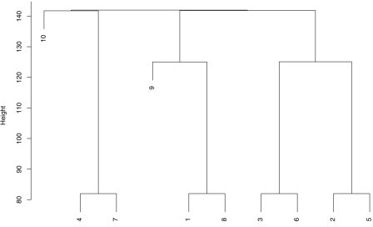

# Diagnostics on Space

To save space, I suppressed the plotting of the results. However, there are plots! In fact there is a set of plots for each alignment step. Here are two of the plots produced if plot = TRUE; these deal with the X-Space which is the search space (the terminology comes from the mlrMBO package which is designed to handle many types of optimization). This plot is for Step 7. The upper plot shows the search space. Axis x1 corresponds to the F1 dimension, and axis x2 the F2 dimension. The red squares represent the initial experimental design, using the results from the objective function. The blue circles represent additional points added as the search proceeds. These represent new points on the response surface defined by the surrogate function (see Part 2 for background). The orange diamond is the best alignment, which in this case has no shift along F2 but a three data point shift along F1; this corresponds to the output above. The green triangle is the last position tested.

The lower plot represents the progress of the search over time. Axis “dob” stands for “date of birth” which is basically the time index of when the test point was added.

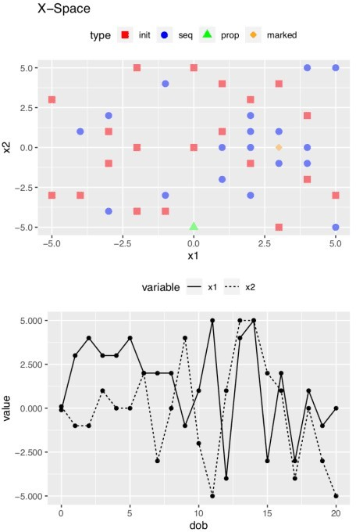

# Diagnostics on the Objective Function

This second set of plots deals with what mlrMBO considers the Y-Space, which concerns the values of the objective function. The top plot is a histogram of the distance (objective function) values; in this case most of them were pretty bad (high, meaning a larger distance between the spectra). The middle plot is the value of the distance over time (dob). In this example the optimal alignment is found at dob = 4, but there is no particular significance to *when* the optimum is found. The lower plot shows the *expected improvement* (ei) at each dob. It is lowest when the optimum has been found. For more details about what’s going on under the

hood, see the Arxiv paper.

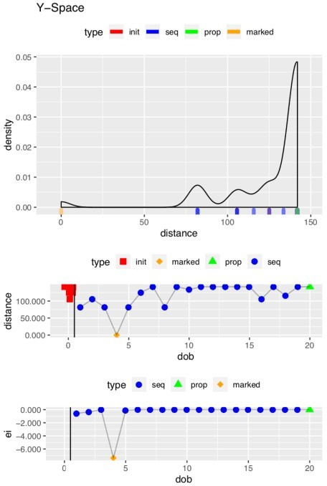

# The Aligned Spectra

Did this process work? This final plot shows that it did. Let’s be clear that the task here was not terribly hard: MUD2 is an artificial example in which the shifts are pretty modest and global in nature. But still, it’s satisfying. I welcome everyone to give hats_alignSpectra2D a try and report any problems or suggestions.

mylvls <- seq(0, 30, length.out = 10 plotSpectra2D(MUD2a, which = c(1, 6), showGrid = TRUE,

lvls = LofL(mylvls, 2),

cols = LofC(c("red", "black"), 2, length(mylvls), 2), main = "Aligned MUD2 Spectra 1 & 6")

